**Assignment No. 05**

**1.Row-Level Trigger**:

A row-level trigger that automatically updates the **no_of_products** field in the **category** table whenever a new product is added or an existing product is deleted.

DELIMITER //

CREATE TRIGGER update_category_product_count

AFTER INSERT ON products

FOR EACH ROW

BEGIN

UPDATE category

SET no_of_products = no_of_products + 1

WHERE category_id = NEW.category_id;

END;

//

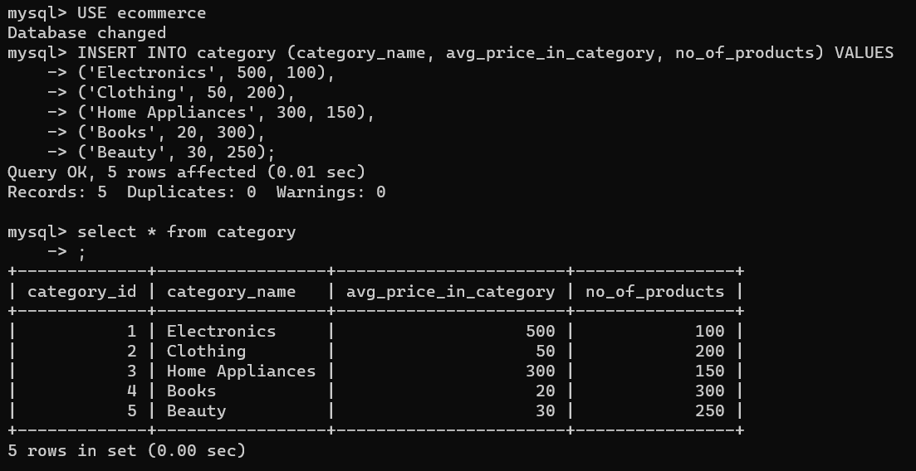DELIMITER ;



